Protection of Alternators
The generating units, especially the larger ones, are relatively few in number and higher in individual
cost than most other equipments. Therefore, it is desirable and necessary to provide protection to
cover the wide range of faults which may occur in the modern generating plant.
Some of the important faults which may occur on an alternator are :
(i) failure of prime-mover (ii) failure of field
(iii) overcurrent (iv) overspeed
(v) overvoltage (vi) unbalanced loading
(vii) stator winding faults
(i) Failure of prime-mover. When input to the prime-mover fails, the alternator runs as a
synchronous motor and draws some current from the supply system. This motoring conditions
is known as “inverted running”.
(a) In case of turbo-alternator sets, failure of steam supply may cause inverted running. If
the steam supply is gradually restored, the alternator will pick up load without disturbing
the system. If the steam failure is likely to be prolonged, the machine can be safely
isolated by the control room attendant since this condition is relatively harmless. Therefore,
automatic protection is not required.
(b) In case of hydro-generator sets, protection against inverted running is achieved by providing
mechanical devices on the water-wheel. When the water flow drops to an insufficient
rate to maintain the electrical output, the alternator is disconnected from the
system. Therefore, in this case also electrical protection is not necessary.
(c) Diesel engine driven alternators, when running inverted, draw a considerable amount of
power from the supply system and it is a usual practice to provide protection against
motoring in order to avoid damage due to possible mechanical seizure. This is achieved
by applying reverse power relays to the alternators which *isolate the latter during their
motoring action. It is essential that the reverse power relays have time-delay in operation
in order to prevent inadvertent tripping during system disturbances caused by faulty
synchronising and phase swinging.
(ii) Failure of field. The chances of field failure of alternators are undoubtedly very rare. Even
if it does occur, no immediate damage will be caused by permitting the alternator to run
without a field for a short-period. It is sufficient to rely on the control room attendant to
disconnect the faulty alternator manually from the system bus-bars. Therefore, it is a universal
practice not to provide †automatic protection against this contingency.
(iii) Overcurrent. It occurs mainly due to partial breakdown of winding insulation or due to
overload on the supply system. Overcurrent protection for alternators is considered unnecessary
because of the following reasons :
(a) The modern tendency is to design alternators with very high values of internal impedance
so that they will stand a complete short-circuit at their terminals for sufficient time
without serious overheating. On the occurrence of an overload, the alternators can be
disconnected manually.
(b) The disadvantage of using overload protection for alternators is that such a protection
might disconnect the alternators from the power plant bus on account of some momentary
troubles outside the plant and, therefore, interfere with the continuity of electric
service.
(iv) Overspeed. The chief cause of overspeed is the sudden loss of all or the major part of load
on the alternator. Modern alternators are usually provided with mechanical centrifugal
devices mounted on their driving shafts to trip the main valve of the prime-mover when a
dangerous overspeed occurs.
(v) Over-voltage. The field excitation system of modern alternators is so designed that overvoltage
conditions at normal running speeds cannot occur. However, overvoltage in an
alternator occurs when speed of the prime-mover increases due to sudden loss of the alternator
load.
In case of steam-turbine driven alternators, the control governors are very sensitive to speed
variations. They exercise a continuous check on overspeed and thus prevent the occurrence of overvoltage
on the generating unit. Therefore, over-voltage protection is not provided on turbo-alternator
sets.
In case of hydro-generator, the control governors are much less sensitive and an appreciable time
may elapse before the rise in speed due to loss of load is checked. The over-voltage during this time
may reach a value which would over-stress the stator windings and insulation breakdown may occur.
It is, therefore, a usual practice to provide over-voltage protection on hydro-generator units. The
over-voltage relays are operated from a voltage supply derived from the generator terminals. The
relays are so arranged that when the generated voltage rises 20% above the normal value, they
operate to
(a) trip the main circuit breaker to disconnect the faulty alternator from the system
(b) disconnect the alternator field circuit
(vi) Unbalanced loading. Unbalanced loading means that there are different phase currents in
the alternator. Unbalanced loading arises from faults to earth or faults between phases on
the circuit external to the alternator. The unbalanced currents, if allowed to persist, may
either severely burn the mechanical fixings of the rotor core or damage the field winding.
Fig. 22.1 shows the schematic arrangement for the protection of alternator against unbalanced
loading. The scheme comprises three line current transformers, one mounted in each phase, having
their secondaries connected in parallel. A relay is connected in parallel across the transformer secondaries.
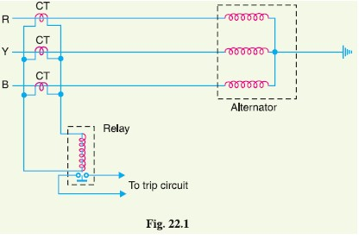
Under normal operating
conditions, equal currents
flow through the different
phases of the alternator and
their algebraic sum is zero.
Therefore, the sum of the currents
flowing in the secondaries
is also zero and no current
flows through the operating coil
of the relay. However, if unbalancing
occurs, the currents
induced in the secondaries will
be different and the resultant of
these currents will flow through
the relay. The operation of the
relay will trip the circuit breaker to disconnect the alternator from the system.
(vii) Stator winding faults. These faults occur mainly due to the insulation failure of the stator
windings. The main types of stator winding faults, in order of importance are :
- fault between phase and ground
(b) fault between phases
(c) inter-turn fault involving turns of the same phase winding
The stator winding faults are the most dangerous and are likely to cause considerable damage to
the expensive machinery. Therefore, automatic protection is absolutely necessary to clear such faults
in the quickest possible time in order to minimise the *extent of damage. For protection of alternators
against such faults, differential method of protection (also knows as Merz-Price system) is most
commonly employed due to its greater sensitivity and reliability. This system of protection is discussed
in the following section.
Differential Protection of Alternators
The most common system used for the protection of stator winding faults employs circulating-current
principle (Refer back to Art. 21.18). In this scheme of protection, currents at the two ends of the
protected section are compared. Under normal operating conditions, these currents are equal but may
become unequal on the occurrence of a fault in the protected section. The difference of the currents
under fault conditions is arranged to pass through the operating coil of the relay. The relay then
closes its contacts to isolate protected section from the system. This form of protection is also known
as Merz-Price circulating current scheme.
Schematic arrangement. Fig. 22.2 shows the schematic arrangement of current differential
protection for a 3-phase alternator. Identical current transformer pairs CT1 and CT2 are placed on
either side of each phase of the stator windings. The secondaries of each set of current transformers
are connected in star ; the two neutral points and the corresponding terminals of the two star groups
being connected together by means of a four-core pilot cable. Thus there is an independent path for
the currents circulating in each pair of current transformers and the corresponding pilot P.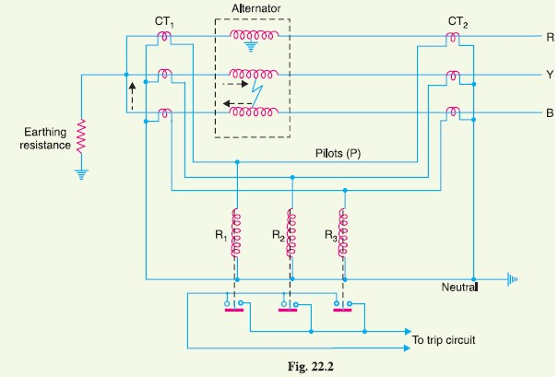
The relay coils are connected in star, the neutral point being connected to the current-transformer
common neutral and the outer ends one to each of the other three pilots. In order that burden
on each current transformer is the same, the relays are connected across equipotential points of the
three pilot wires and these equipotential points would naturally be located at the middle of the pilot
wires. The relays are generally of electromagnetic type and are arranged for instantaneous action
since fault should be cleared as quickly as possible.
Operation. Referring to Fig. 22.2, it is clear that the relays are connected in shunt across each
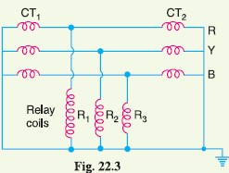
circulating path. Therefore, the circuit of Fig. 22.2 can be
shown in a simpler form in Fig. 22.3. Under normal operating
conditions, the current at both ends of each winding
will be equal and hence the currents in the secondaries of
two CTs connected in any phase will also be equal. Therefore,
there is balanced circulating current in the pilot wires
and no current flows through the operating coils (R1, R2
and R3) of the relays. When an earth-fault or phase-to-phase
fault occurs, this condition no longer holds good and the
differential current flowing through the relay circuit operates
the relay to trip the circuit breaker.
(i) Suppose an earth fault occurs on phase R due to breakdown of its insulation to earth as
shown in Fig. 22.2. The current in the affected phase winding will flow through the
core and frame of the machine to earth, the circuit being completed through the neutral
earthing resistance. The currents in the secondaries of the two CTs in phase R will
become unequal and the difference of the two currents will flow through the corresponding
relay coil (i.e. R1), returning via the neutral pilot. Consequently, the relay
operates to trip the circuit breaker.
(ii) Imagine that now a short-circuit fault occurs between the phases Y and B as shown in
Fig. 22.2. The short-circuit current circulates via the neutral end connection through
the two windings and through the fault as shown by the dotted arrows. The currents in
the secondaries of two CTs in each affected phase will become unequal and the differential
current will flow through the operating coils of the relays (i.e. R2 and R3) connected
in these phases. The relay then closes its contacts to trip the circuit breaker.
It may be noted that the relay circuit is so arranged that its energising causes (i) opening of the
breaker connecting the alternator to the bus-bars and (ii) opening of the *field circuit of the alternator.
It is a prevailing practice to mount current transformers CT1 in the neutral connections (usually in
the alternator pit) and current transformers CT2 in the switch-gear equipment. In some cases, the
alternator is located at a considerable distance from the switchgear. As the relays are located close to
the circuit breaker, therefore, it is not convenient to connect the relay coils to the actual physical midpoints
of the pilots. Under these circumstances, balancing resistances are inserted in the shorter
lengths of the pilots so that the relay tapping points divide the whole secondary impedance of two sets
of CTs into equal portions. This arrangement is shown in Fig. 22.4. These resistances are usually
adjustable in order to obtain the exact balance.
Limitations. The two circuits for alternator protection shown above have their own limitations.
It is a general practice to use neutral earthing resistance in order to limit the destructive effects of
earth-fault currents. In such a situation, it is impossible to protect whole of the stator windings of a
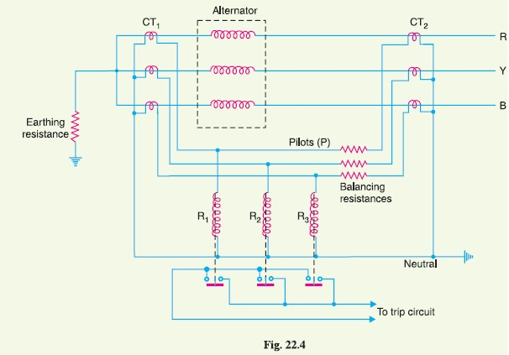
star-connected alternator during earth-faults. When an earth-fault occurs near the neutral point, there

may be insufficient voltage across the short-circuited portion to drive the necessary current round the
fault circuit to operate the relay. The magnitude of unprotected zone depends upon the value of
earthing resistance and relay setting.
Makers of protective gear speak of “protecting 80% of the winding” which means that faults in
the 20% of the winding near the neutral point cannot cause tripping i.e. this portion is unprotected. It
is a usual practice to protect only 85% of the winding because the chances of an earth fault occurring
near the neutral point are very rare due to the uniform insulation of the winding throughout.
Balanced Earth-fault Protection
In small-size alternators, the neutral ends of the three-phase windings are often connected internally
to a single terminal. Therefore, it is not possible to use Merz-Price circulating current principle
described above because there are no facilities for accommodating the necessary current transformers
in the neutral connection of each phase winding. Under these circumstances, it is considered sufficient
to provide protection against earth-faults only by the use of balanced earth-fault protection scheme.
This scheme provides no protection against phase-to-phase faults, unless and until they develop into
earth-faults, as most of them will.
Schematic arrangement. Fig. 22.6 shows the schematic arrangement of a balanced earth-fault
protection for a 3-phase alternator. It consists of three line current transformers, one mounted in each
phase, having their secondaries connected in parallel with that of a single current transformer in the
conductor joining the star point of the alternator to earth. A relay is connected across the transformers
secondaries. The protection against earth faults is limited to the region between the neutral and
the line current transformers.
Operation. Under normal operating conditions, the currents flowing in the alternator leads and
hence the currents flowing in secondaries of the line current transformers add to zero and no current
flows through the relay. Also under these conditions, the current in the neutral wire is zero and the
secondary of neutral current transformer supplies no current to the relay.
If an earth-fault develops at F2 external to the protected zone, the sum of the currents at the
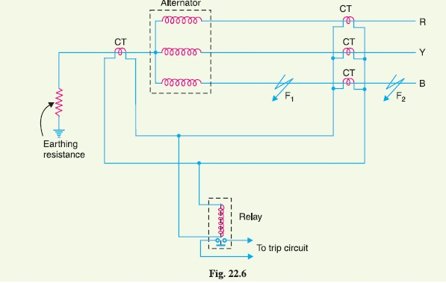
terminals of the alternator is exactly equal to the current in the neutral connection and hence no

current flows through the relay. When an earth-fault occurs at F1 or within the protected zone, these
currents are no longer equal and the differential current flows through the operating coil of the relay.
The relay then closes its contacts to disconnect the alternator from the system.

Protection of Transformers
Transformers are static devices, totally enclosed and generally oil immersed. Therefore, chances of
faults occurring on them are very rare. However, the consequences of even a rare fault may be very
serious unless the transformer is quickly disconnected from the system. This necessitates to provide
adequate automatic protection for transformers against possible faults.
Small distribution transformers are usually connected to the supply system through series fuses
instead of circuit breakers. Consequently, no automatic protective relay equipment is required. However,
the probability of faults on power transformers is undoubtedly more and hence automatic protection
is absolutely necessary.
Common transformer faults. As compared with generators, in which many abnormal conditions
may arise, power transformers may suffer only from :
(i) open circuits
(ii) overheating
(iii) winding short-circuits e.g. earth-faults, phase-to-phase faults and inter-turn faults.
An open circuit in one phase of a 3-phase transformer may cause undesirable heating. In practice,
relay protection is not provided against open circuits because this condition is relatively harmless.
On the occurrence of such a fault, the transformer can be disconnected manually from the
system.
Overheating of the transformer is usually caused by sustained overloads or short-circuits and
very occasionally by the failure of the cooling system. The relay protection is also not provided
against this contingency and thermal accessories are generally used to sound an alarm or control the
banks of fans.
Winding short-circuits (also called internal faults) on the transformer arise from deterioration of
winding insulation due to overheating or mechanical injury. When an internal fault occurs, the transformer
must be disconnected quickly from the system because a prolonged arc in the transformer may
cause oil fire. Therefore, relay protection is absolutely necessary for internal faults.
22.7 Protection Systems for Transformers
For protection of generators, Merz-Price circulating-current system is unquestionably the most satisfactory.
Though this is largely true of transformer protection, there are cases where circulating current
system offers no particular advantage over other systems or impracticable on account of the
troublesome conditions imposed by the wide variety of voltages, currents and earthing conditions
invariably associated with power transformers. Under such circumstances, alternative protective
systems are used which in many cases are as effective as the circulating-current system. The principal
relays and systems used for transformer protection are :
(i) Buchholz devices providing protection against all kinds of incipient faults i.e. slow-developing
faults such as insulation failure of windings, core heating, fall of oil level due to leaky
joints etc.
(ii) Earth-fault relays providing protection against earth-faults only.
(iii) Overcurrent relays providing protection mainly against phase-to-phase faults and overloading.
(iv) Differential system (or circulating-current system) providing protection against both earth
and phase faults.
The complete protection of transformer usually requires the combination of these systems. Choice
of a particular combination of systems may depend upon several factors such as (a) size of the transformer
(b) type of cooling (c) location of transformer in the network (d) nature of load supplied and
(e) importance of service for which transformer is required. In the following sections, above systems
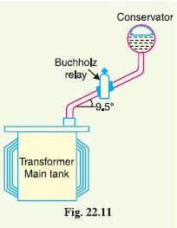
of protection will be discussed in detail.
22.8 Buchholz Relay
Buchholz relay is a gas-actuated relay installed in oil immersed
transformers for protection against all kinds of faults.
Named after its inventor, Buchholz, it is used to give an alarm
in case of incipient (i.e.
slow-developing) faults in
the transformer and to disconnect
the transformer
from the supply in the
event of severe internal faults. It is usually installed in the pipe connecting the conservator to the main tank as shown in Fig. 22.11. It is a universal practice to use Buchholz relays on all such oil immersed transformers having ratings in *excess of 750 kVA.
Construction. Fig. 22.12 shows the constructional details of a Buchholz relay. It takes the form
of a domed vessel placed in the connecting pipe between the main tank and the conservator. The
device has two elements. The upper element consists of a mercury type switch attached to a float.
The lower element contains a mercury switch mounted on a hinged type flap located in the direct path
of the flow of oil from the transformer to the conservator. The upper element closes an alarm circuit
during incipient faults whereas the lower element is arranged to trip the circuit breaker in case of
severe internal faults.
Operation. The operation of Buchholz relay is as follows :
(i) In case of incipient faults within the transformer, the heat due to fault causes the decomposition
of some transformer oil in the main tank. The products of decomposition contain
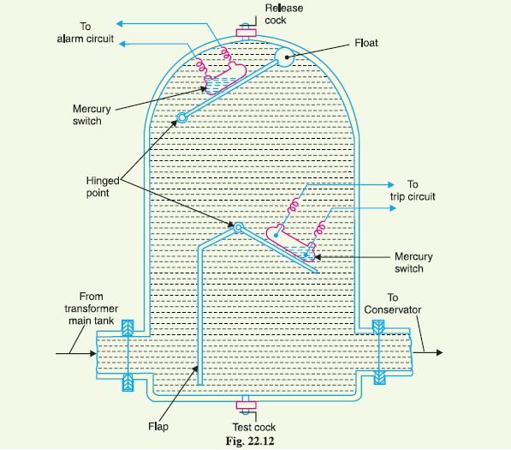
more than 70% of hydrogen gas. The hydrogen gas being light tries to go into the conservator

and in the process gets entrapped in the upper part of relay chamber. When a predetermined
amount of gas gets accumulated, it exerts sufficient pressure on the float to
cause it to tilt and close the contacts of mercury switch attached to it. This completes the
alarm circuit to sound an *alarm.
(ii) If a serious fault occurs in the transformer, an enormous amount of gas is generated in the
main tank. The oil in the main tank rushes towards the conservator via the Buchholz relay
and in doing so tilts the flap to close the contacts of mercury switch. This completes the trip
circuit to open the circuit breaker controlling the transformer.
Advantages
(i) It is the simplest form of transformer protection.
(ii) It detects the incipient faults at a stage much earlier than is possible with other forms of
protection.
Disadvantages
(i) It can only be used with oil immersed transformers equipped with conservator tanks.
(ii) The device can detect only faults below oil level in the transformer. Therefore, separate
protection is needed for connecting cables.

Busbar Protection
Busbars in the generating stations and sub-stations form important link between the incoming and outgoing circuits.If a fault occurs on a busbar, considerable damage and disruption of supply will occur unless some form of quick-acting automatic protection is provided to isolate the faulty busbar. The busbar zone, for the purpose of protection,
includes not only the busbars themselves but also the isolating switches, circuit breakers and the
associated connections. In the event of fault on any section of the busbar, all the circuit equipments
connected to that section must be tripped out to give complete isolation.
The standard of construction for busbars has been very high, with the result that bus faults are
extremely rare. However, the possibility of damage and service interruption from even a rare bus
fault is so great that more attention is now given to this form of protection. Improved relaying
methods have been developed, reducing the possibility of incorrect operation. The two most commonly
used schemes for busbar protection are :
(i) Differential protection (ii) Fault bus protection
(i) Differential protection. The basic method for busbar protection is the differential scheme
in which currents entering and leaving the bus are totalised. During normal load condition, the sum of
these currents is equal to zero. When a fault occurs, the fault current upsets the balance and produces
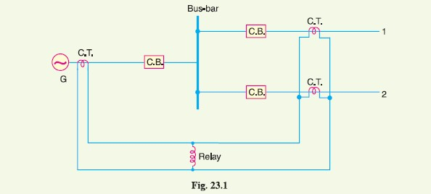
a differential current to operate a relay.

Fig. 23.1 shows the single line diagram of current differential scheme for a station busbar. The
busbar is fed by a generator and supplies load to two lines. The secondaries of current transformers
in the generator lead, in line 1 and in line 2 are all connected in parallel. The protective relay is
connected across this parallel connection. All CTs must be of the same ratio in the scheme regardless
of the capacities of the various circuits. Under normal load conditions or external fault conditions,
the sum of the currents entering the bus is equal to those leaving it and no current flows through the
relay. If a fault occurs within the protected zone, the currents entering the bus will no longer be equal
to those leaving it. The difference of these currents will flow through the relay and cause the opening
of the generator, circuit breaker and each of the line circuit breakers.
(ii) Fault Bus protection. It is possible to design a station so that the faults that develop are
mostly earth-faults. This can be achieved by providing earthed metal barrier (known as fault bus)
surrounding each conductor throughout its entire length in the bus structure. With this arrangement,
every fault that might occur must involve a connection between a conductor and an earthed metal
part. By directing the flow of earth-fault current, it is possible to detect the faults and determine their
location. This type of protection is known as fault bus protection.
Fig. 23.2 show the schematic arrangement of fault bus protection. The metal supporting structure
or fault bus is earthed through a current transformer. A relay is connected across the secondary
of this CT. Under normal operating conditions, there is no current flow from fault bus to ground and
the relay remains inoperative. A fault involving a connection between a conductor and earthed supporting structure will result in current flow to ground through the fault bus, causing the relay to
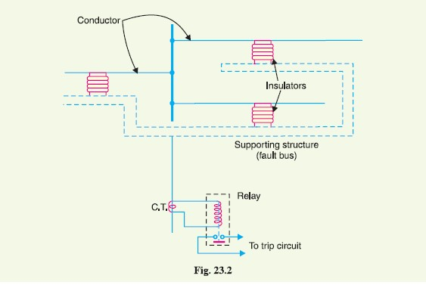
operate. The operation of relay will trip all breakers connecting equipment to the bus.

Protection of Lines
The probability of faults occurring on the lines is much more due to their greater length and exposure
to atmospheric conditions. This has called for many protective schemes which have no application to
the comparatively simple cases of alternators and transformers. The requirements of line protection
are :
(i) In the event of a short-circuit, the circuit breaker closest to the fault should open, all other
circuit breakers remaining in a closed position.
(ii) In case the nearest breaker to the fault fails to open, back-up protection should be provided
by the adjacent circuit breakers.
(iii) The relay operating time should be just as short as possible in order to preserve system
stability, without unnecessary tripping of circuits.
The protection of lines presents a problem quite different from the protection of station apparatus
such as generators, transformers and busbars. While differential protection is ideal method for
lines, it is much more expensive to use. The two ends of a line may be several kilometres apart and to
compare the two currents, a costly pilot-wire circuit is required. This expense may be justified but in
general less costly methods are used. The common methods of line protection are :
(i) Time-graded overcurrent protection (ii) Differential protection (iii) Distance protection
Differential Pilot-Wire Protection
The differential pilot-wire protection is based on the principle that under normal conditions, the
current entering one end of a line is equal to that leaving the other end. As soon as a fault occurs
between the two ends, this condition no longer holds and the difference of incoming and outgoing
currents is arranged to flow through a relay which operates the circuit breaker to isolate the faulty
line. There are several differential protection schemes in use for the lines. However, only the following two schemes will be discussed :
1. Merz-Price voltage balance system
2. Translay scheme
1. Merz-Price voltage balance system. Fig. 23.8 shows the single line diagram of Merz-
Price voltage balance system for the protection of a 3-phase line. Identical current transformers are
placed in each phase at both ends of the line. The pair of CTs in each line is connected in series with
a relay in such a way that under normal conditions, their secondary voltages are equal and in opposition
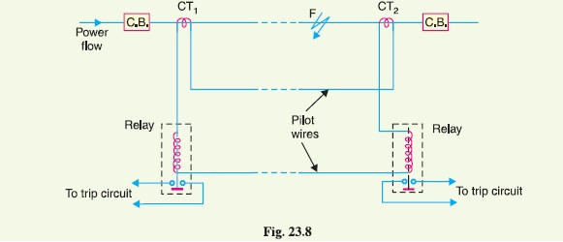
i.e. they balance each other.

Under healthy conditions, current entering the line at one-end is equal to that leaving it at the
other end. Therefore, equal and opposite voltages are induced in the secondaries of the CTs at the two
ends of the line. The result is that no current flows through the relays. Suppose a fault occurs at point
F on the line as shown in Fig. 23.8. This will cause a greater current to flow through CT1 than through
CT2. Consequently, their secondary voltages become unequal and circulating current flows through
the pilot wires and relays. The circuit breakers at both ends of the line will trip out and the faulty line
will be isolated.
Fig. 23.9 shows the connections of Merz-Price voltage balance scheme for all the three phases of
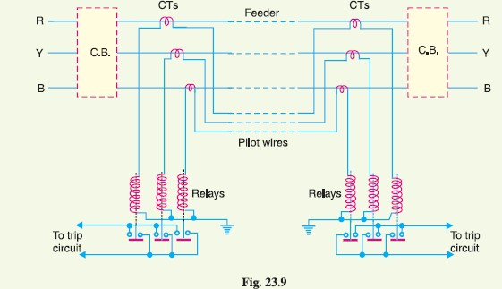
the line.

Advantages
(i) This system can be used for ring mains as well as parallel feeders.
(ii) This system provides instantaneous protection for ground faults. This decreases the possibility
of these faults involving other phases.
(iii) This system provides instantaneous relaying which reduces the amount of damage to overhead
conductors resulting from arcing faults.
Disadvantages
(i) Accurate matching of current transformers is very essential.
(ii) If there is a break in the pilot-wire circuit, the system will not operate.
(iii) This system is very expensive owing to the greater length of pilot wires required.
(iv) In case of long lines, charging current due to pilot-wire capacitance* effects may be sufficient
to cause relay operation even under normal conditions.
(v) This system cannot be used for line voltages beyond 33 kV because of constructional difficulties
in matching the current transformers.

